# GCST Digital Service Accessibility Corporation

horizontal line

260 Victoria St.

Glassboro, NJ 08028

(856) 256-4000

[gbadeb45@students.rowan.edu](mailto:gbadeb45@students.rowan.edu)

March 27, 2023

Dear Reader,

We are pleased to offer you this report on our discovery on the issue with digital accessibility on Rowan University’s Glassboro campus and the solutions we have developed to help the problem.

As we have come to learn, Rowan University’s staff and students have had issues pertaining to network connectivity and access. In many parts of the campus, these networks are often slow during high parts of the day and tedious to use. In addition to slow speeds, the networks are often completely unavailable due to overload on the network and constant maintenance. To combat this, Rowan WiFi can 1) add additional network access points throughout the campus to balance the network load; 2) upgrade network devices of the more popular network points on campus with the most up-to-date hardware available; 3) finally, Rowan can completely overhaul all existing network equipment. These three options have their pros and cons as discussed in the report. However, the cost of each option will not surpass the $10,000,000 threshold given.

Digital accessibility is an extremely important tool that faculty and students need on any campus. And what we present in this report is work we have meticulously done in hopes to better digital access across Rowan University. We are glad to present this with the goal of effecting for change for this university’s digital landscape.

Sincerely,

Gershom Gbadebo

horizontal line

# GCST Digital Service Accessibility Corporation

horizontal line

# Improved Network Access on Rowan University



Recommendation Report on the important needs of digital accessibility on around Rowan University's Campus

Christian Cmur, Gershom Gbadebo, Eric Toal,Dylan Simoncelli

Secondary Researcher, Editor, Primary Researcher, Project Manager

This document encompasses a table of contents section, executive summary, references, appendices and other descriptions and conclusions from our work.

horizontal line

# Table of Contents

horizontal line

**GCST Digital Service Accessibility Corporation 1**

**Improved Network Access on Rowan University 2**

**Table of Contents 3**

**Executive Summary 4**

**Introduction: The Need for Digital Accessibility 5**

**Background: The Importance of Digital Accessibility in Rowan University 6**

**Requirements & Criteria 9**

**Discussion of Options 11**

**Comparative Analysis 13**

Option 1 - Additional Network Coverage 13

Option 2 - Upgrade Popular Network Locations 13

Option 3 - Complete Overhaul 14

**Summary Table 15**

**Recommendation 16**

**References 18**

**Appendix A 19**

Surveyed Data 19

Figure 1 - WiFi Speeds Around Rowan University Glassboro Campus 19

Figure 2 - College Demographic 20

Figure 3 - Experienced Issues with Digital Services? 20

Figure 4 - Rowan Digital Services Issues Breakdown 21

Figure 5 - Commuter or Non-Commuter? 21

Digital Access Conversation 22

Key Takeaways From the Digital Access Conversation 22

horizontal line

# Executive Summaryhorizontal line

As previously mentioned, digital accessibility is becoming increasingly important to the success of student education and our professors’ learning environment. This recommendation report aims to explore the common issues found in Rowan University’s digital accessibility through primary and secondary research. Our primary researcher conducted surveys and interviews for first hand information from Rowan students and faculty. We discovered that access to Wifi is the major issue when considering digital accessibility. In order to improve Rowan’s Wifi speed and access to it, we must consider the needs and criteria. Our solution must increase Wifi coverage around campus while also increasing the load capacity. The solution can’t exceed $10 million over a 5 year span, while ensuring that two-factor authentication remains in place for security reasons. The environmental impacts of the solution must be as little as possible. These criteria are utilized in deciding possible solutions, stating the description of options, and conducting the comparative analysis. The restrictions, needs, and possible solutions for digital accessibility shaped our final recommendation which is to increase network access points in popular areas around campus. The process of coming to this recommendation through research and logistics will be thoroughly explained throughout this report.

# 

horizontal line

# 

# Introduction: The Need for Digital Accessibility

horizontal line

Rowan University’s student population has been growing at a steady rate for many years. The growth of the University has bolstered the administration's willingness to greenlight multiple construction projects around campus in order to keep the College both up to date and capable of withstanding the expanding student population. As the number of students grows, the infrastructure of the University is stretched thin, this can be seen in many aspects such as parking, roadway congestion, student housing, etc. Within this proposal however, we seek to improve upon the area of internet accessibility on and around campus. With one of the most popular majors of the school being Computer Science, access to WiFi will undoubtedly be the largest area in need of improvement in the near future.

*Source: https://irt.rowan.edu/_images/banners/catalog/wireless.jpg*

The WiFi at Rowan University is generally more frustrating than it

should be. Our proposal seeks to improve the quality of the WiFi around campus as well as expanding access to it at the same time. To achieve this, it will require improvements to existing WiFi technologies, as well as expanding the current number of hotspots around campus.

horizontal line

# Background: The Importance of Digital Accessibility in Rowan Universityhorizontal line

Digital accessibility is an important feature in a college setting. Many Rowan students and faculty need digital access for RowanWiFi, Rowan Self Service Banner, Canvas and online classes, email services, accessing certain buildings on campus, the list goes on. Without proper access, stakeholders cannot utilize certain Rowan tools. This affects not only faculty performance, but many other aspects of Rowan’s digital space.

Many Rowan stakeholders have voiced their concerns as found through our research. For example, Rowan students who have impairments are forced to deal with poor accessibility options for Canvas and Self Service Banner. While accessibility support does exist in Canvas, it can be unstable and inconsistent. Self-service Banner is insufficiently inclusive of all impairments, but could possibly take advantage of accessibility improvements to the Banner API. In addition to this, there is an accessibility process students must go through and this can be difficult to deal with digitally.

*Source:* [*https://irt.rowan.edu/_images/services/catalog/icons/network/eduroam.jpg*](https://irt.rowan.edu/_images/services/catalog/icons/network/eduroam.jpg)



Rowan WiFi has proven troublesome for the vast majority. In certain, popular areas on campus, WiFi is incredibly slow (See Figure 1). Slow speeds means many stakeholders cannot access emails, Canvas, Banner, or other digital resources to carry out their work. These major connection issues are nothing new, and can be easily traced back several years. In an article written by Rowan’s campus newspaper the authors stated that the registration website crashed as juniors were attempting to schedule their senior fall semester classes (The Whit Staff, 2017). The morning of registration is a vital period for students, especially seniors, to pick classes and professors before the enrollment is filled. If the registration website crashes, this creates a large amount of unnecessary stress for seniors that need to set up their semester in order to graduate.

Sometimes, lab rooms are unavailable for students that need access to computers and certain software that exists on these machines. Without access, many students are unable to carry out their work. Some buildings are also inaccessible due to lockout issues with Rowan ID’s. These ID’s are finicky and unreliable many times leaving students without a space to carry out their work.

We ran a survey which had 18 respondents, all of whom were students in the age range of 17-25. The majority of these respondents were commuter students who require non-residential spaces for work on campus. Figure 2 shows a breakdown of demographic information for the people who had issues with Rowan Digital Services. Figure 3 shows a comparison of those who had no issue with Rowan digital services, and those who had issues. Figure 4 divides issues with digital services into Rowan WiFi and other digital services.

The plan of action is to get firsthand knowledge not only for ourselves, but from other Rowan stakeholders. Getting information from the source will greatly determine how we carry this task out. Certain students and faculty members will have knowledge and experience on certain digital

*Source:* [*https://www.google.com/url?sa=i&url=https%3A%2F%2Fwww.vecteezy.com%2Ffree-vector%2Faction-plan&psig=AOvVaw2XIbaRcdWbNpZF7EoFXfKf&ust=1680276829117000&source=images&cd=vfe&ved=0CAMQjB1qFwoTCPCviZH9g_4CFQAAAAAdAAAAABAh*](https://www.vecteezy.com/free-vector/action-plan)

accessibility issues that other students will not. The time spent by the stakeholder will matter drastically: first or second year Rowan students and faculty may have different insights and understandings

that Rowan vets do not and vice versa. Regardings students specifically, their college and the classes they take. Regarding Rowan faculty, their position on campus. Another major factor, commuters versus those who stay at Rowan, their insights will most likely be different. Older Rowan stakeholders might have a different outlook on digital accessibility than younger stakeholders. Another big factor is the quantity of people we get information from. The more people we reach, the better our conclusion will be. If we reach less people we may have more in depth information on certain issues that a large audience may not be able to give us. In addition, how we get information matters a lot. Emailing a poll to people may cause them to comfortably express their opinions and issues as opposed to in-person questioning which may be uncomfortable and awkward for both parties.

horizontal line

# Requirements & Criteria

# horizontal line

Here is the list of requirements and criteria for each solution listed below:

*Source: https://img.freepik.com/premium-vector/audit-document-icon-comic-style-result-report-vector-cartoon-illustration-white-isolated-background-verification-control-business-concept-splash-effect_157943-8622.jpg?w=2000*

* $10M/5 years, two-factor authentication must remain
  + Two-factor authentication and other security features should remain if possible. Weaker security would prove costly in the long run as Rowan’s network would become more susceptible to potential cyber attacks and breaches.
* Minimal environmental impact, costs account for environment
  + Regardless of the steps taken to improve this situation, it should not have substantial adverse effects on the environment. Potential upgrades should not cause more issues in the future resulting in more energy waste or overall use.
* Must expand stakeholder access to Rowan digital services.
* Must keep in mind Diversity, Equity, and Inclusion so that historically disadvantaged and underrepresented stakeholder populations are not overlooked during this process.

horizontal line

# Discussion of Options

# horizontal line

*Source:* [*https://approvedmodems.org/arris-s33-review/*](https://approvedmodems.org/arris-s33-review/)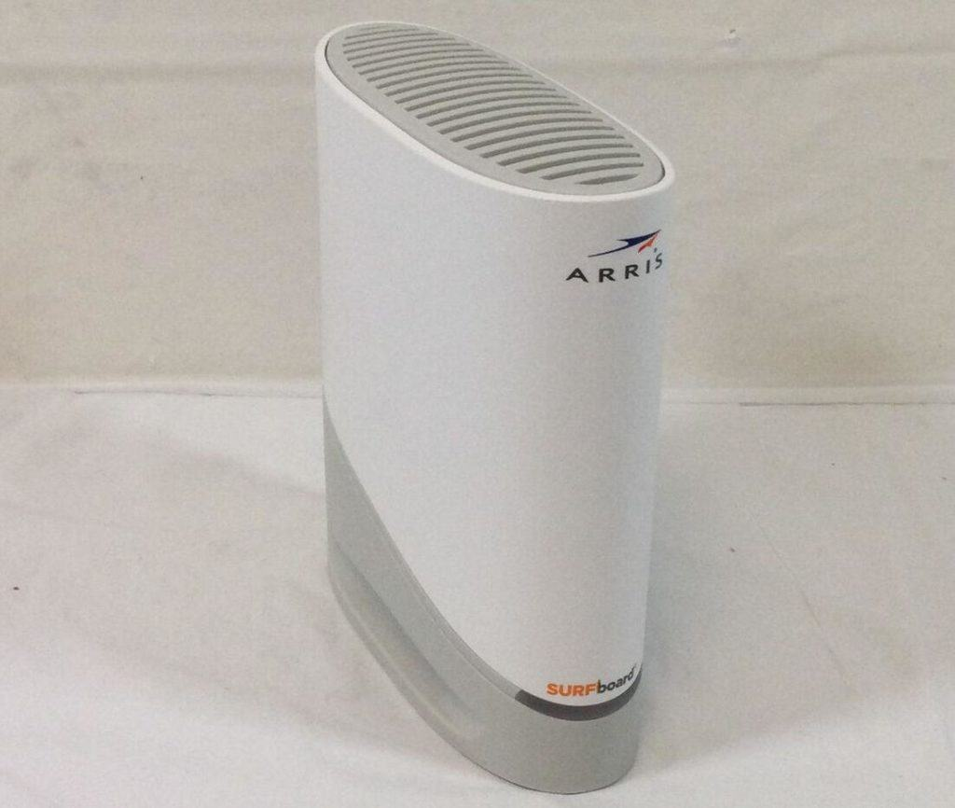

* Add additional network access points in more popular areas
  + Through the more popular network locations on campus, we can place more network access points. Including wireless access points (WAPs) onto the network will do this. The first step would be connecting the access point to a few of the modems that provide Rowan internet through ethernet. Afterwards, we would set up the access points SSID which would be RowanWiFi. Next we would set up the wireless channel for the access point, either 1, 6 or 11 depending on the channel the wireless routers are set to. Next we set up encryption for the access point, which in this case would require the same authentication RowanWiFi utilizes. Finally we test the access points and ensure they work up to par.
    - Students and faculty would have better WiFi upload and download speeds. Rowan would also have less connectivity issues all together.
    - There would also be more flexibility as faculty and students are able to switch between networks given one is slower than another.
    - Certain on-campus equipment and other services that require network connectivity could carry out their service without having to sacrifice performance.
* Upgrade most popular network locations
  + First, we need to upgrade the cables that transmit data, the ethernet and coaxial (coax) cables. The latest generation Ethernet standard is Cat 8. The cable supports speeds up to 25 to 40 Gbps depending on the length as well as a standard bandwidth around 2,000 MHz. This is over two times faster than the standard Cat6a cables many universities use for cost purposes. These cables are also shielded meaning they can be run both indoors and outdoors. After upgrading the ethernet cables, we upgrade the coaxial cables to the KabelDirekt 242 coaxial cables. These cables transmit with maximum quality regardless of distance. There is reduced signal loss and increased durability as these cables are dual-layer shielded with thick aluminum and aluminum mylar foil also helping protect the interior copper line and everyday wear and tear these cables likely endure.
    - Would increase load capacity and network speed of targeted locations with better network equipment
    - Upgrading these would see Rowan University’s current infrastructure used to its full potential
* Complete overhaul of all networking systems
  + A wireless network needs connection from an Internet Service Provider (ISP), a quality cable modem router and matching network cables to match. In this option, we would upgrade all current network modems to the ARRIS SURFboard S33. Comcast, Spectrum and Cox all support this modem. There are 32 channels going down and 8 going up. This is at least double the capability of many other competing modems for sale. And with listed download and upload speeds of 5,000/2,000 Mbps, respectively, this modem provides far more sheer power to the Rowan network.
    - Would likely be too costly and take too much time
    - According to our primary research, this option would be redundant, as the infrastructure Rowan has is very advanced, but the avenues in which its distributes to students is problematic

horizontal line

# Comparative Analysis

# horizontal line

All options must meet 3 baseline criteria:

1. Must ultimately make the system more accessible after completion
2. Project time must not exceed 5 years or cause significant interruptions
3. Must stay within the $10,000,000 budget

## Option 1 - Additional Network Coverage

Criteria 1: This would certainly make the access of internet around campus much better.

Criteria 2: It’s unlikely that this project would exceed a 5 year timespan, but in order to house additional hotspots, new locations would have to be dedicated to these network locations. This could interrupt some locations on campus, but not significantly.

Criteria 3: Unlikely to exceed a $10 million budget.

## Option 2 - Upgrade Popular Network Locations

Criteria 1: While the locations of accessibility would stay the same, the stress that the locations can withstand would be significantly greater.

Criteria 2: This option would likely not take more than 5 years or cause any major disruptions on campus. Existing housing locations for the current WiFi locations can be reused, but may need to be upgraded to suit more advanced systems.

Criteria 3: Unlikely to exceed budget.

*Source:* [*https://www.s1ecos.com/selection-criteria-e-invoicing-solution/*](https://www.s1ecos.com/selection-criteria-e-invoicing-solution/)

## Option 3 - Complete Overhaul

Criteria 1: Would likely increase accessibility in all aspects, however the current internet infrastructure on campus is already relatively advanced, so improvements would be minor.

Criteria 2: This will likely take more than 5 years. In addition, a complete overhaul would create major disruptions to campus.

Criteria 3: Extremely likely to exceed budget.

horizontal line

# Summary Table

# horizontal line

|  | **Criteria 1 (accessibility)** | **Criteria 2 (implementation)** | **Criteria 3 (cost)** |
| --- | --- | --- | --- |
| **Option 1: Add additional network coverage around campus** | Increased network access around campus | Less than 5 years to implement but new locations would be dedicated to the additional hotspots | Less than $10 million |
| **Option 2: Upgrade most popular network locations** | Better networks would be able to withstand more stress | More than 5 years to implement and no major disruptions would be caused, but potential upgrades to housing locations may be needed | Less than or equal to $10 million |
| **Option 3: Overhaul all current network locations** | Improvements would be minor compared to current network implementation | More than 5 years to implement and major disruptions to network would be caused | Far more than $10 million |

horizontal line

# Recommendationhorizontal line

The best plan of action recommended is to upgrade the more widely used network locations on the campus. As per figure 1 below, the Robinson Hall and Campbell Library areas have the lowest speed of all surveyed areas. As a result, network connection will be slow and oftentimes unreliable for students and other staff as well as additional network usages. To combat this, we should first upgrade the modems for this network. The ARRIS SURFboard S33 is a powerful modem that not only supports Comcast, Spectrum and Cox, but hosts 32 channels going down and 8 going up. This means far more bandwidth and general speed for the modem to handle. Furthermore, the cables that transmit this data will need to be upgraded.

*Source:* [*https://www.duarte.com/wp-content/uploads/Nurture_Banner_DataStory-Blog-Nurture-Banner_Adopt-Reco_03_AM-01.png*](https://www.duarte.com/wp-content/uploads/Nurture_Banner_DataStory-Blog-Nurture-Banner_Adopt-Reco_03_AM-01.png)

The latest standard cable being used today is Cat 8. This standard supports speeds up to 25 to 40 Gbps and standard bandwidth of around 2,000 MHz making it two times faster than standard Cat6a cables many universities use due to cost. The modems will need a stronger connection from the Internet Service Provider Rowan uses. Here is where coaxial cables need to be upgraded to the KabelDirekt 242 coaxial cables. While this is only one of a list of capable cables, these cables transmit with maximum quality regardless of distance. There is also reduced signal loss and increased durability as these cables are dual-layer shielded with thick aluminum and aluminum mylar foil also helping 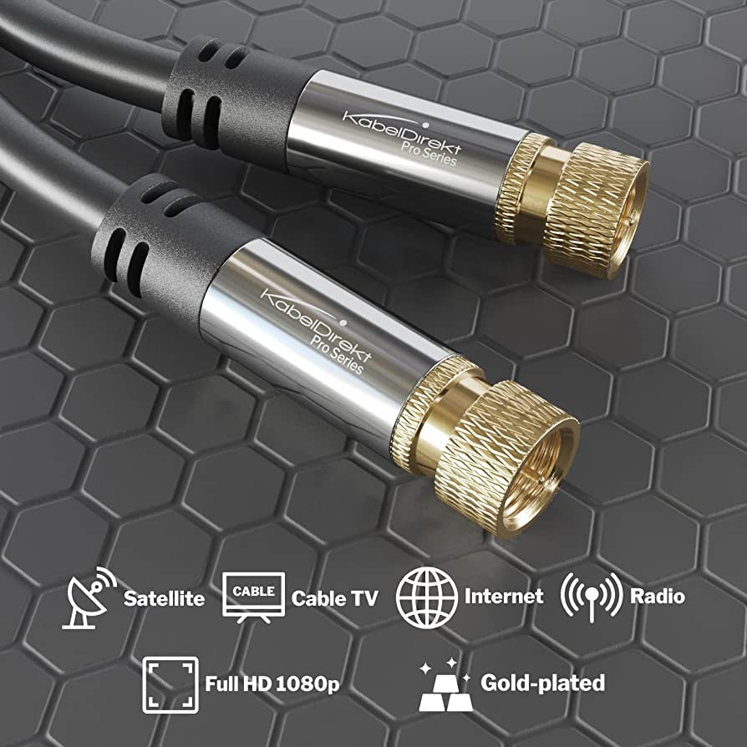

*Source:* [*https://www.amazon.com/CableDirect-Satellite-Multi-Layer-Break-Proof-connectors/dp/B00DI890PM*](https://www.amazon.com/CableDirect-Satellite-Multi-Layer-Break-Proof-connectors/dp/B00DI890PM)

protect the interior copper line and everyday wear and tear these cables likely endure. These upgrades would cost less than the budget at hand and will last for more than 5 years due to practicality and ease of implementation.

horizontal line

# Referenceshorizontal line

*Rowan University Academics & Majors - US News Best Colleges. (n.d.). Rowan University.* [*https://www.usnews.com/best-colleges/rowan-university-2609/academics*](https://www.usnews.com/best-colleges/rowan-university-2609/academics)

*The Whit Staff. (2017, March 22). Rowan's internet issues are embarrassing . The Whit Online. Rowan University. Retrieved March 5, 2023, from* [*https://www.thewhitonline.com/2017/03/opinion/editorial-rowans-internet-issues-are-embarrassing/*](https://www.thewhitonline.com/2017/03/opinion/editorial-rowans-internet-issues-are-embarrassing/)

*Track the Total Number of Students at Rowan Year by Year. (2022, July 26). College Tuition Compare.* [*https://www.collegetuitioncompare.com/trends/rowan-university/student-population/*](https://www.collegetuitioncompare.com/trends/rowan-university/student-population/)

horizontal line

# Appendix Ahorizontal line

## **Surveyed Data**

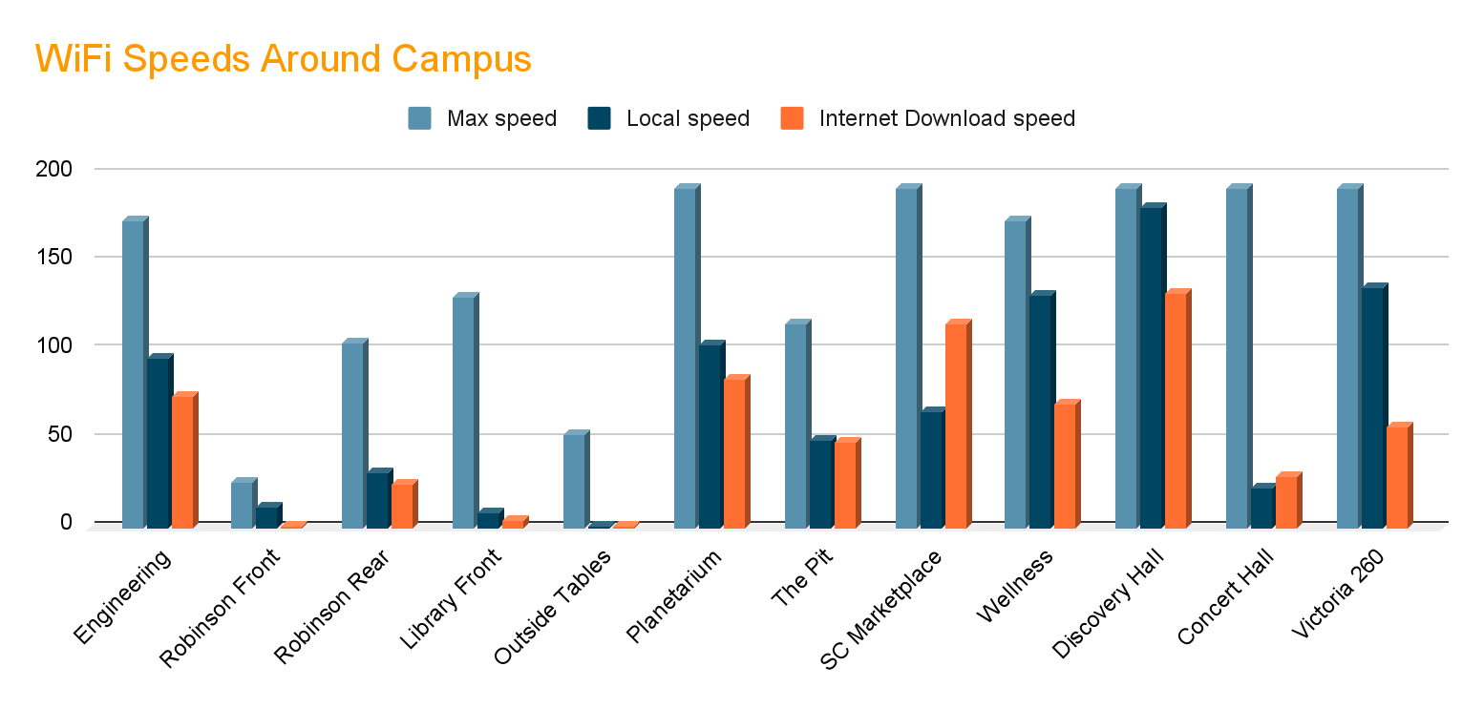

## **Figure 1 - WiFi Speeds Around Rowan University Glassboro Campus**

From the graph it is apparent that certain buildings not only have slower speeds than others, but even with few devices the speeds are generally low. Outside areas like the tables behind the Library and Savitz Hall are designed to allow people to congregate outside, which is typically great for physical and mental health. However, those people will have trouble working out there due to connectivity issues. Places like the Engineering Hall, Planetarium, and Discovery Hall are reliably fast, but they have limited space for people to work. The Student Center Marketplace has reliably fast WiFi and plenty of space, but is a dining area. Many people there will be using the WiFi for data hungry digital content applications, which can create bandwidth bottlenecks when the space is occupied by many people. Also, the Marketplace is noisy and can be difficult to work in.

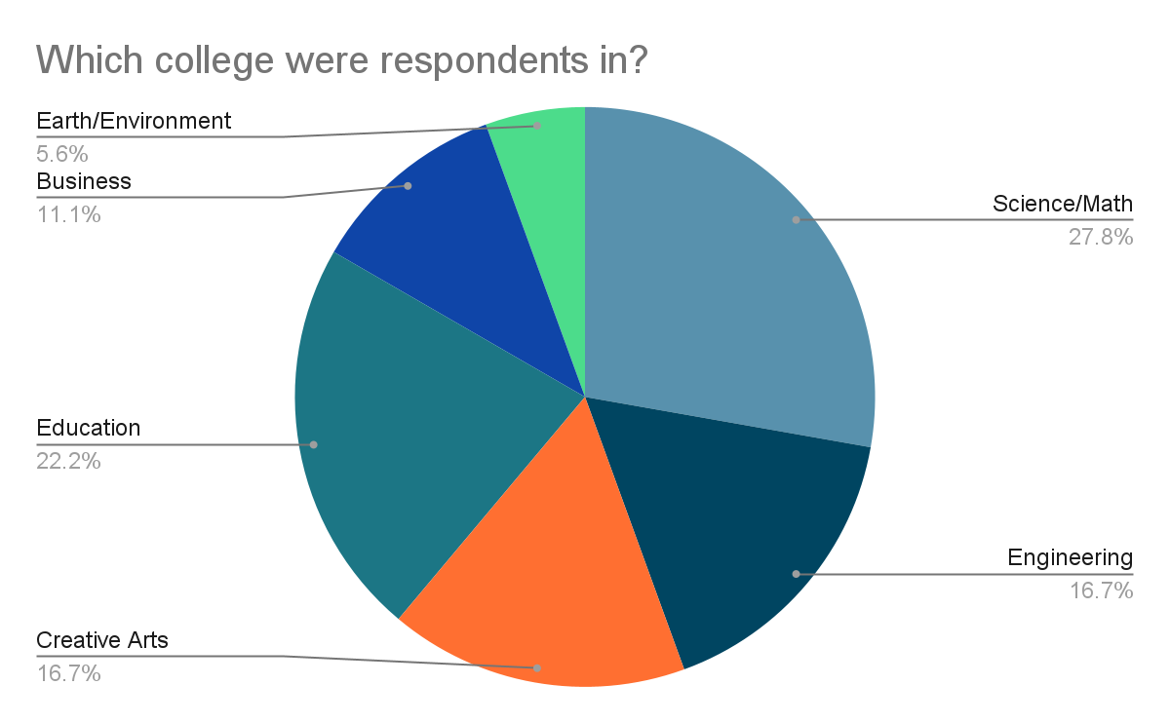

## Figure 2 - College Demographic

*Demographic breakdown of survey respondents by college.*

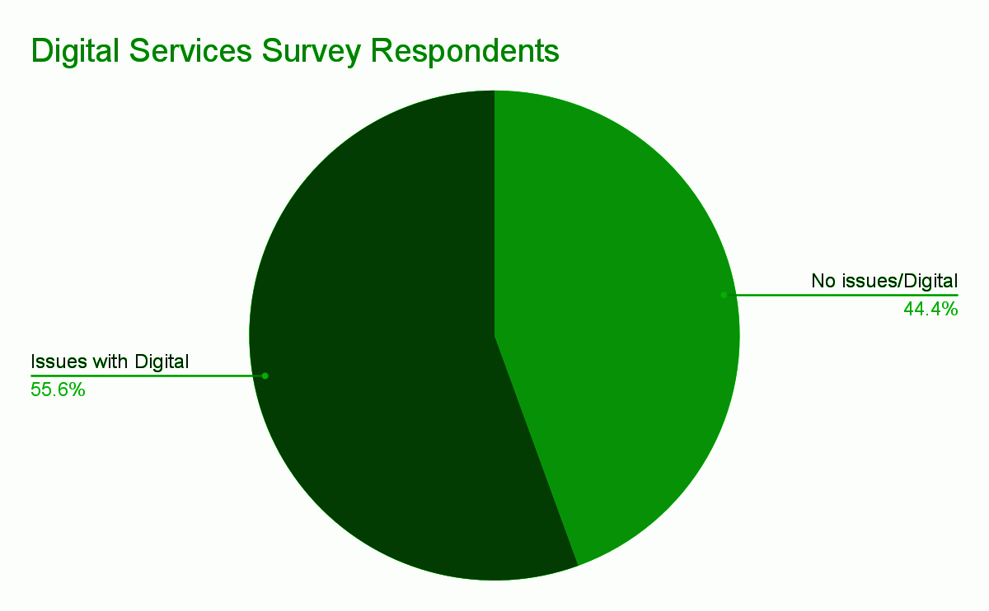

## Figure 3 - Experienced Issues with Digital Services?

*There was a larger portion of survey respondents who had previous issues with Rowan digital services.*

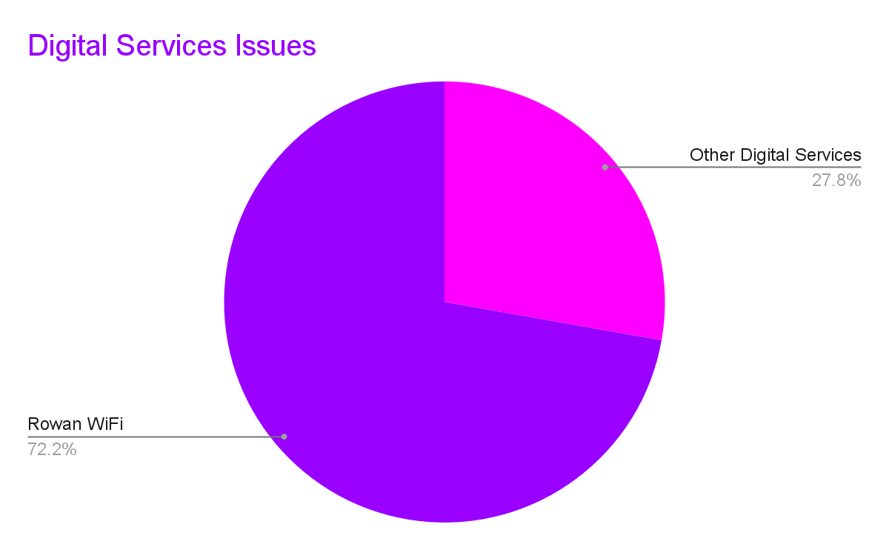

## Figure 4 - Rowan Digital Services Issues Breakdown

*More than 70% of respondents who reported issues with digital services reported that the issue was with Rowan’s WiFi.*

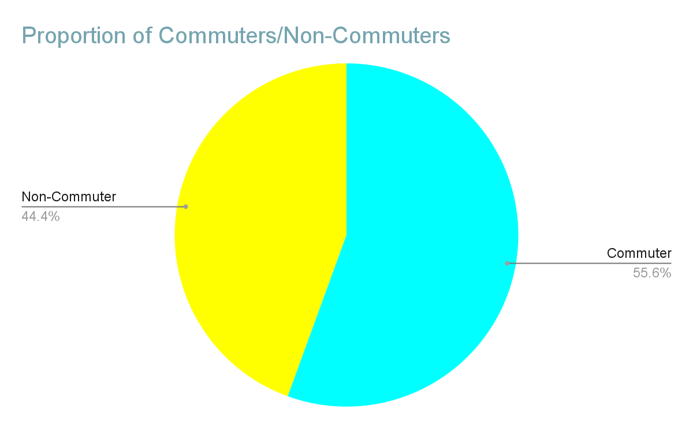

## Figure 5 - Commuter or Non-Commuter?

*Commuters represent the larger portion of survey respondents who have issues with Rowan Digital Services.*

## **Digital Access Conversation**

*Here are the major discussion points and answers we obtained from a sit-down discussion with a Senior Architect with Rowan’s IT department*

What are the primary causes of digital services interruptions? Planned maintenance, overload, some services can be attacked by hostile actors.

What are some issues maintaining reliable speeds on campus? How many people are using the WiFi in a given area, limitations of equipment, space for extra equipment in a given area, a given wireless band only has so much bandwidth, proximity to WiFi equipment, and mediums between source of the signal and devices.

What are some challenges providing reliable WiFi at outside congregation areas? Hard to find places for equipment that can provide the speeds people want (extra wear and tear if the equipment is not adequately protected). There is a lower priority for high bandwidth applications in these areas, because they are not ideal places for these purposes.

## **Key Takeaways From the Digital Access Conversation**

Extra equipment, especially at points user devices enter the network, could increase WiFi usability.

However, extra equipment needs to occupy space and needs to be physically protected, which will come with unique challenges in buildings like Robinson or outside congregation areas.

Digital services can have interruptions for a few reasons. An example given was the registration system and how registration is staggered because of the load on the registration system. Even then, registration is a crazy time just because overload is still possible with all of the traffic to Rowan’s web services.

They seem to own some of their Fiber infrastructure here, some of which is owned by Rowan.

horizontal line